Supervising and Mentoring Students: A Resource for TAs and Graduate Students
Mentoring students can be very rewarding. Having a clear understanding of how you will be a mentor in your context, the ‘goals’ of each mentorship relationship, and clear communication and boundaries can foster a great mentoring experience. This resource describes what mentorship is, as well as the benefits of mentorship for both the mentor and mentee. This resource also includes links to video reflections from McMaster TAs and graduate students who have served as mentors.

You might be wondering what student to student mentorship looks like. It can manifest formally, such as being asked to train a student in your research context, or from a classroom role, such as being a TA. Formal mentorship usually has a structured set of rules regarding the frequency and length of meetings, the types of activities involved, and respective roles and responsibilities. Mentors and mentees may also be expected to engage in networking events and workshops.

Informal mentorships are formed between mentees and mentors based on individual needs and or interests. Typically, these relationships develop organically and without the structured events formal mentorships have. They can also stem from settings such as tutorials or lab-groups. Roles and responsibilities are negotiated, and fluid, and the mentorship may extend beyond the institution and become more personal in nature.

Watch this video to hear about both formal and informal mentoring experienced by McMaster graduate students Megan, Shawn, and Lisa.

Mentorship Defined
Before reading on, think about how you would define mentorship. What good experiences have you had in the past and how do they inform your definition? You can also draw on the experiences of Allison, Megan, Shawn, and Lisa discussed in this video. While definitions of mentoring vary across studies and programs, there are four points of consensus about the characteristics of a mentorship relationship (Crisp & Cruz, 2009).
- Mentorship focuses on the growth and development of mentees, such as navigating a new situation.

- Relative to their mentees, mentors have “more” of something (e.g., expertise, knowledge, skill). The mentor is a “helping hand.” This does not necessarily mean the mentor is in a position of higher authority.

- Mentoring experiences include broad forms of support; professional, emotional, and / or psychological.

- Mentoring relationships are personal and reciprocal. Mentors and mentees have responsibility in the relationship and are aware of and interested in pursuing a mentorship relationship. As Shawn and Lisa describe in the above video, the relationship is bi-directional – both parties benefit from the experience.

Ultimately, as a mentor, you’re invested in your mentee’s positive outcomes, demonstrating emotional commitment beyond the communication of academic requirements. You care about your mentee’s professional and personal development, and advocate on their behalf.

Benefits of Mentorship
This table summarizes the benefits of mentorship (Dolan & Jonson, 2009) as Lisa, Megan, Allison, and Shawn discuss in this video.

Mentor | Mentee
Emotional growth | Gaining confidence and autonomy (Shawn and Megan elaborate in this video)
Career preparation and promotion | Having someone to ask for advice
Communication and conflict resolution | Have someone to provide insight and context
Time management | Achievement of goals

Many jobs require the ability to serve as a mentor to others. Your experience as a mentor can be included in a resume, curriculum vitae, and teaching portfolio, where appropriate. Consider including the name of the mentee (with permission), the project they worked on / position they held (if applicable), and a testimonial of their experience working with you as their mentor.

Finding a Mentorship Opportunity
Below is a list of some of the formal mentorship programs available at McMaster University:

- Anthropology Skills and Knowledge Mentorship Program – A mentorship program where graduate students volunteer their time to answer questions that undergraduate students may have about anthropology.
- Indigenous Mentorship Program – Helps dismantle barriers to post-secondary education for First Nations, Inuit, and Métis students coming into or already within the Faculty of Health Sciences. Each year, Indigenous students are recruited from all areas of the Faculty of Health Sciences and related health programs to be Mentors.
- Graduate Student Shadowing in The Faculty of Science – Offers undergraduate students an opportunity to shadow graduate students in research environments. The program aids students in determining whether they would like to conduct research at the undergraduate or graduate level and provides them with opportunities to network

Starting A Mentorship Relationship
In this video, Lisa, Shawn, and Allison talk about the importance of setting expectations and finding common ground when beginning a new mentorship relationship. Related, Masters and Keeger (2017) have developed several guidelines to help mentors and mentees express their expectations (see the “Guidelines for Cultivating A Mentoring Relationship” infographic).
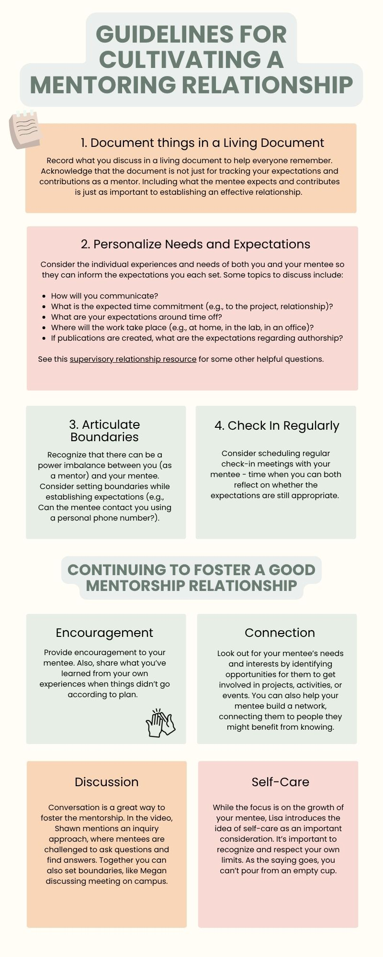

Alternative text for infographic: 5 Guidelines for cultivating a mentoring relationship
- Document things in a Living Document: Record what you discuss in a living document to help everyone remember. Acknowledge that the document is not just for tracking your expectations and contributions as a mentor. Including what a mentee expects and contributes is just as important to establishing an effective relationship.
- Personalize Needs and Expectations: Considering the individual experiences and needs of both you and your mentee so they can inform expectations you each set. Some topics to discuss include:
  - How will we communicate?
  - What is the expected time commitment (e.g., to the project, relationship)?
  - What are our expectations around time off?
  - Where will the work take place (e.g., at home, in the lab, in an office)?

If publications are being created, what are the expectations around authorship?
See this supervisory relationship resource for some other helpful questions.
- Articulate Boundaries: Recognize that there can be a power imbalance between you as a mentor and the mentee. Consider setting boundaries while establishing expectations (e.g., can the mentee contact you using a personal phone number?).
- Check in Regularly: Consider scheduling regular check-in meeting with your mentee—time when you can both reflect on whether your expectations are still appropriate.
Continuing to Foster a Good Mentorship Relationship
Encouragement: Provide encouragement to your mentee. Also, share what you’ve learned from your own experiences when things didn’t go according to plan.
Connection: Look out for your mentee’s needs and interests by identifying opportunities to get involved in projects, activities, or events. You can help your mentee build a network by connecting them to people they might benefit from knowing.
Discussion: Conversation is a great way to foster the mentorship. In the video, Shawn mentions an inquiry approach, where mentees are challenged to ask questions and find answers. Together you can also set boundaries, like Megan discussing meeting on campus.
3-Self Care: While the focus is on the growth of your mentee, Lisa introduces the idea of self-care as an important consideration. It’s important to recognize and respect your own limits. As the saying goes, you can’t pour from an empty cup.

Fostering Mentorship
Shawn, Lisa, and Megan give advice on continuing a mentorship relationship in this video. There may be difficult conversations during a mentorship, and in this video the graduate student mentors discuss the value of active listening. Some suggestions for tough talks include:
- Focusing comments on what the mentee has just said.
- Using probing questions (“Why do you think that is?”)
- Validating the mentee’s ideas and checking for clarity by rephrasing (“If I understand correctly, you’re saying…”)
- Including the mentee in decision-making, as appropriate. If your mentee comes to you with a challenge they’ve experienced, ask, “How have you tried to address this?” Being involved in the process will help them be committed to making changes.
Listen to some final words of wisdom from Lisa and Shawn in this video.

References and Additional
Chiappetta-Swanson, C., & Watt, S. (2011). Good practice in the supervision and mentoring of postgraduate students: It takes an academy to raise a scholar. McMaster University, Centre for Leadership in Learning.
Crisp, G., Baker, V. L., Griffin, K. A., Lunsford, L. G., & Pifer, M. J. (2017). Mentoring undergraduate students: ASHE higher education report. John Wiley & Sons.
Crisp, G., & Cruz, I. (2009). Mentoring college students: A critical review of the literature between 1990 and 2007. Research in Higher Education, 50(6), 525–545. https://doi.org/10.1007/s11162-009-9130-2
Dolan, E., Johnson, D. (2009). Toward a Holistic View of Undergraduate Research Experiences: An Exploratory Study of Impact on Graduate/Postdoctoral Mentors. Journal of Science Education and Technology 18 (5), 487–500. https://doi.org/10.1007/s10956-009-9165-3
Dolan, E., & Johnson, D. (2010). The undergraduate–postgraduate–faculty triad: Unique functions and tensions associated with undergraduate research experiences at research universities. CBE—Life Sciences Education, 9(4), 543–553. https://doi.org/10.1187/cbe.10-03-0052
Masters, K. S., & Kreeger, P. K. (2017). Ten simple rules for developing a mentor–mentee expectations document. PLoS Computational Biology, 13(9), e1005709. https://doi.org/10.1371/journal.pcbi.1005709
Reddick, R. J., Griffin, K. A., Cherwitz, R. A., Cérda-Pražák, A. A., & Bunch, N. (2012). What you get when you give: How graduate students benefit from serving as mentors. Journal of Faculty Development, 26(1), 37–49. https://eric.ed.gov/?id=EJ979218
University of Washington, UW Graduate School. (n.d.). What a good mentor does. https://grad.uw.edu/current-students/student-success/mentoring/#:~:text=A%20mentor%20provides%20you%20with,department%20life%20and%20career%20choices

